Exercises: Unit Testing Lists
Submit your solutions here: https://judge.softuni.org/Contests/5199/Unit-Testing-Lists-Exercise

Unit Test List: Number Processor
Test a given method which takes in a list of integers and adds each number in a new list following these principles:
- If the number is even, it squares it.
- If the number is odd, it square roots it.
The method is found in the NumberProcessor.cs file:
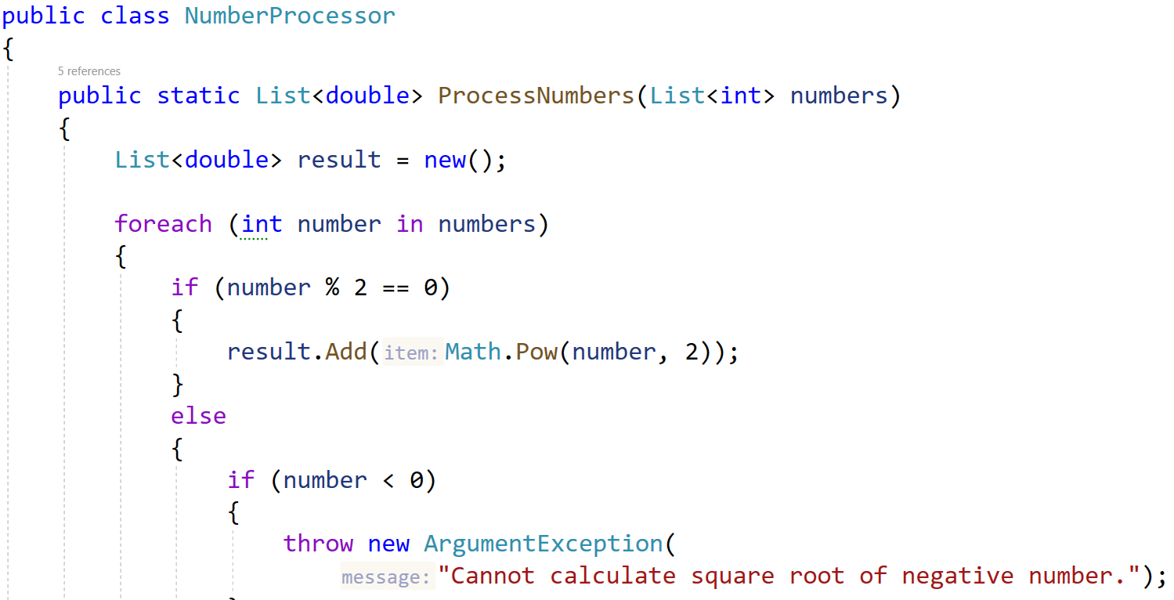
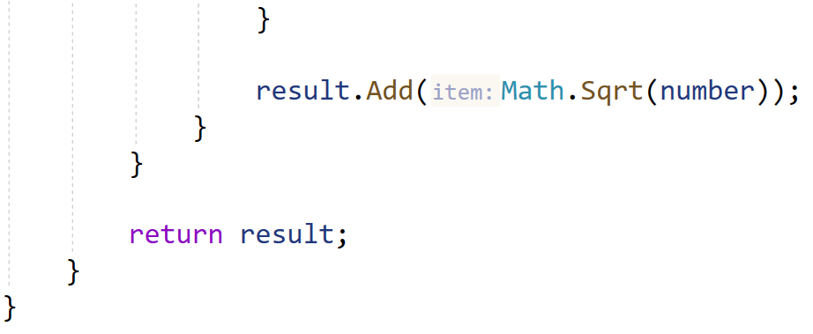
In the test file NumberProcessorTest.cs you are given tests. Finish them and run them:
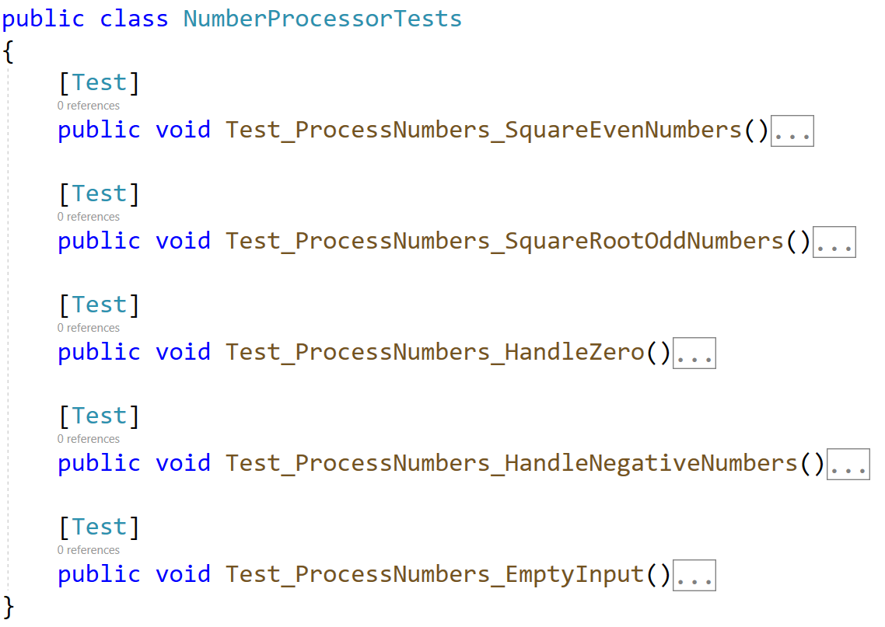

Unit Test List: Palindrome
Test a given method which takes in a list of strings and checks if every word in the list is a palindrome.
The method is found in the Palindrome.cs file:
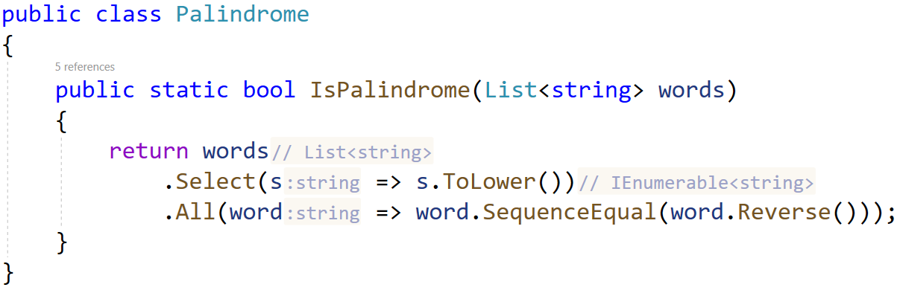
In the test file PalindromeTests.cs you are given 2 partially finished test, and 3 empty tests. Finish them and run them:
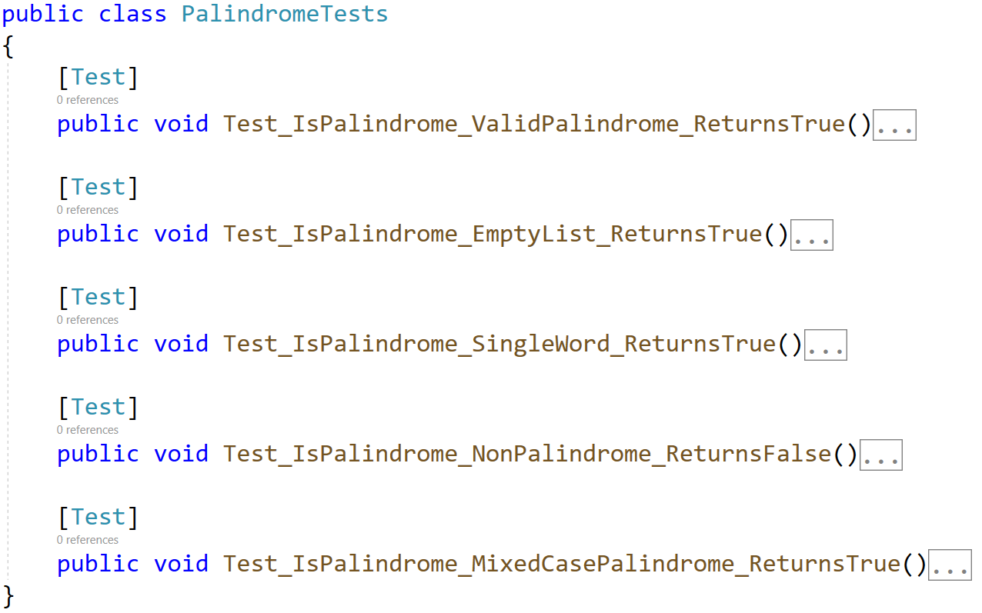
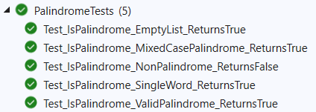

Unit Test List: Matrix
Test a given method which takes in 2 lists of list of integers (matrix) that performs matrix addition on them.
The method is found in the Matrix.cs file:
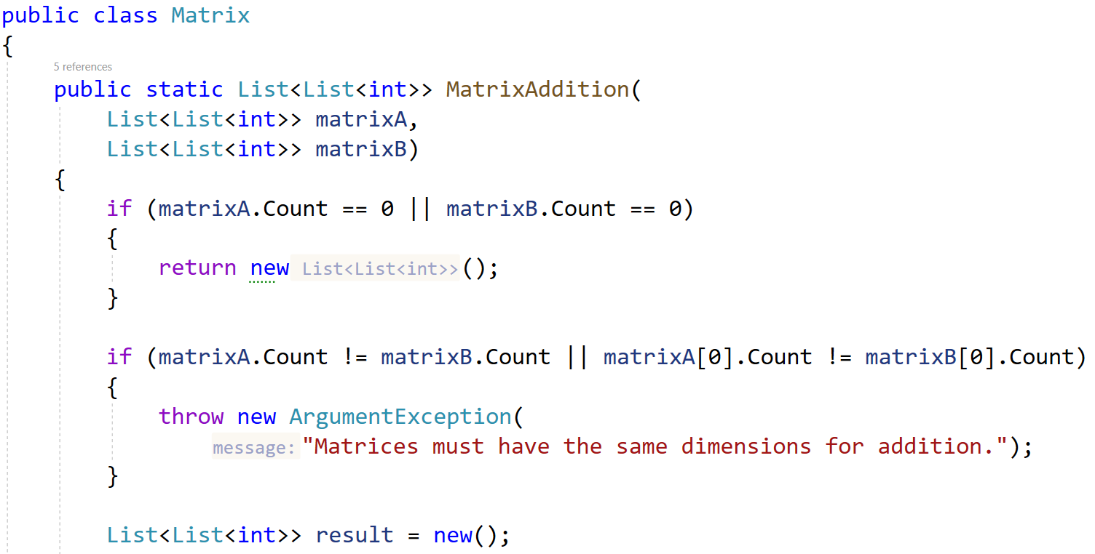
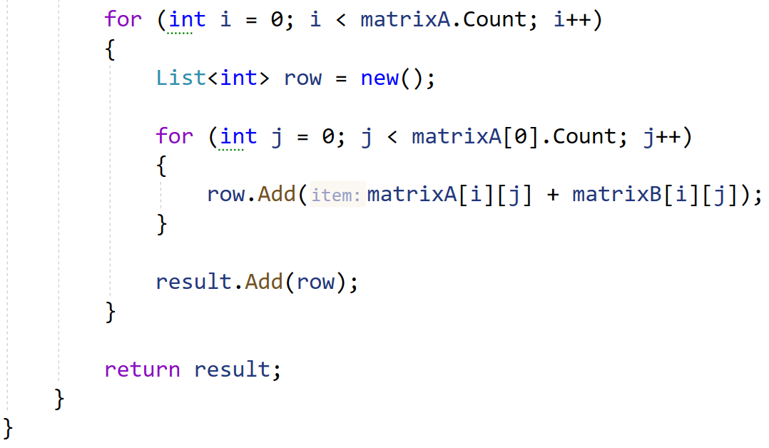
Notice the method throws ArgumentException if the matrices are not the same length.
In the test file MatrixTests.cs you are given 2 partially finished test, and 3 empty tests:
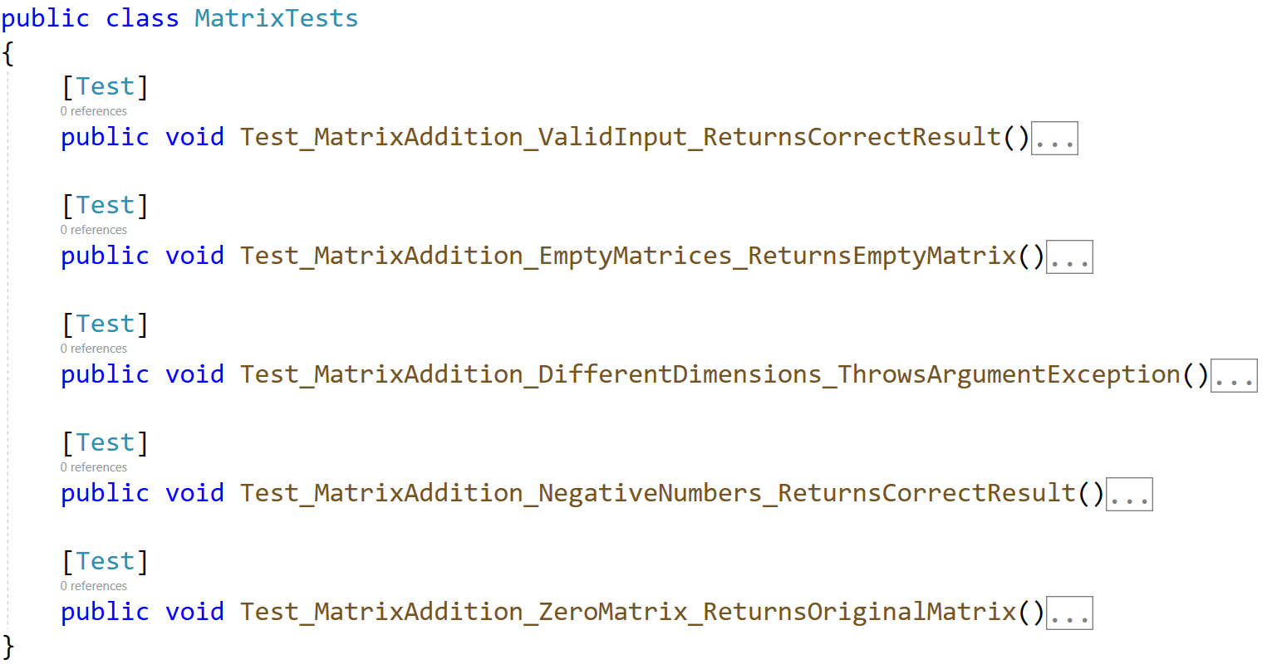
Check the tests run successfully:
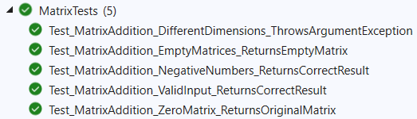

Unit Test List: Find Same Values
Test a method that takes two lists of integers as input and returns a new list containing the unique integers that are present in both input lists. The method ensures that each value in the result appears only once, even if it appears multiple times in the input lists.
The method is found in the SameValues.cs file:
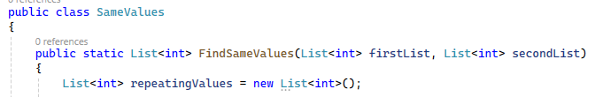
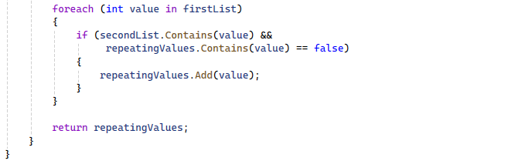
You are given a test file TopIntegersTests.cs containing 4 empty tests:
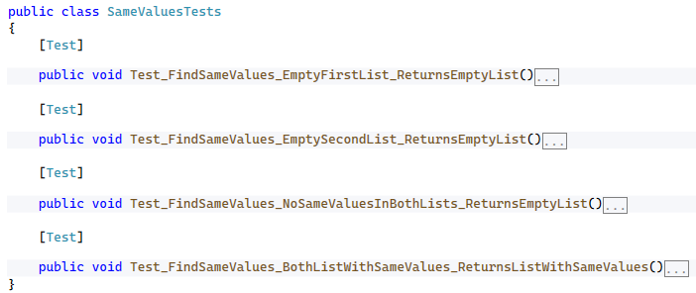
When you are ready make sure your tests run:
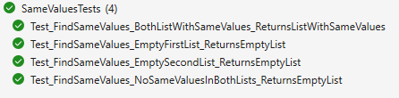

Unit Test List: Remove Greater Than Threshold
Test a method that takes in a list of integers and an integer threshold. The method should return a new list that contains only the integers from the original list that are less than or equal to the threshold.
The method is found in the ListRemover.cs file:
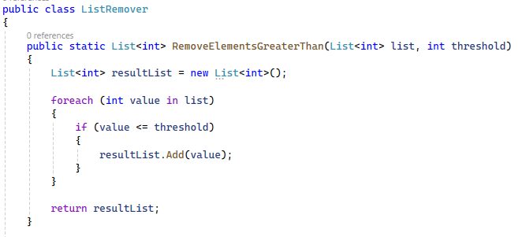
You are given a test file ListRemover_RemoveGreaterThanTests.cs containing 4 empty tests:
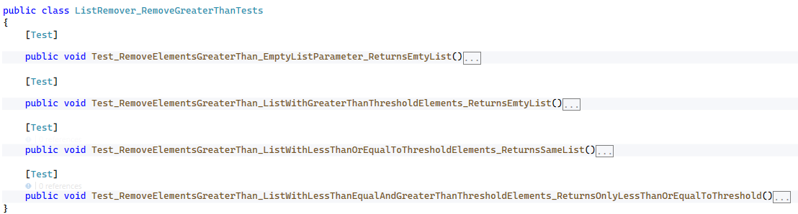
When you are ready make sure your tests run:
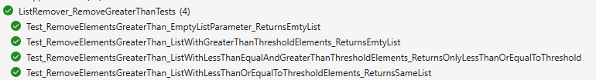

Unit Test List: Remove Less Than or Equal to Threshold
Test a method that takes in a list of integers and an integer threshold. The method should return a new list that contains only the integers from the original list that are greater than the threshold.
The method is found in the ListRemover.cs file:
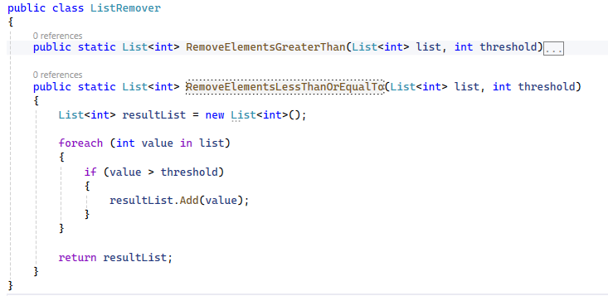
You are given a test file ListRemover_RemoveLessThanOrEqualToTests.cs containing 4 empty tests:
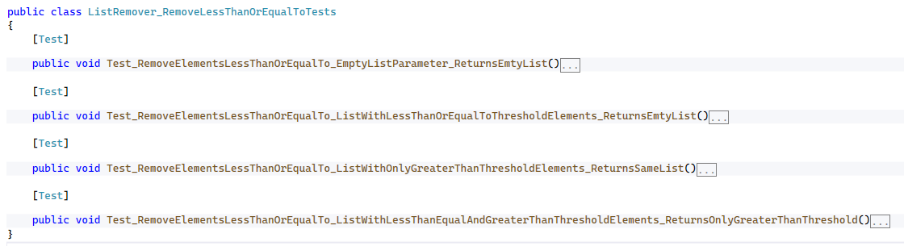
When you are ready make sure your tests run:
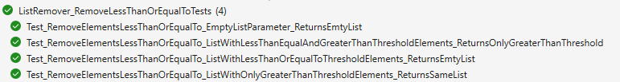

Unit Test List: List Splitter
Test a method that takes in a list of integers and splits it into two separate lists: one containing all even numbers and the other containing all odd numbers.
Note: The method's return type is (List<int> evens, List<int> odds), which is a tuple consisting of two List<int> objects.
The method is found in the ListSplitter.cs file:
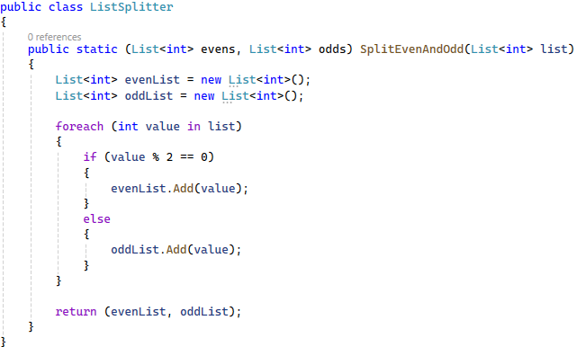
You are given a test file ListSplitterTests.cs containing 4 empty tests:
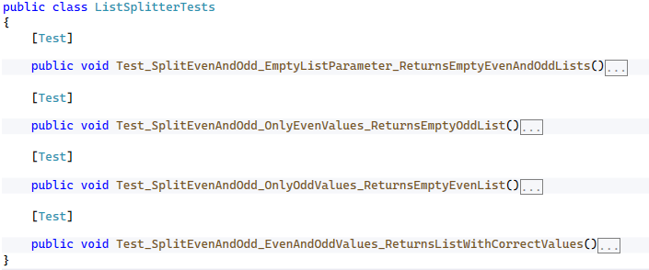
When you are ready make sure your tests run:
